**Grayscaling and Thresholding (Black & White effect)**

Image for post

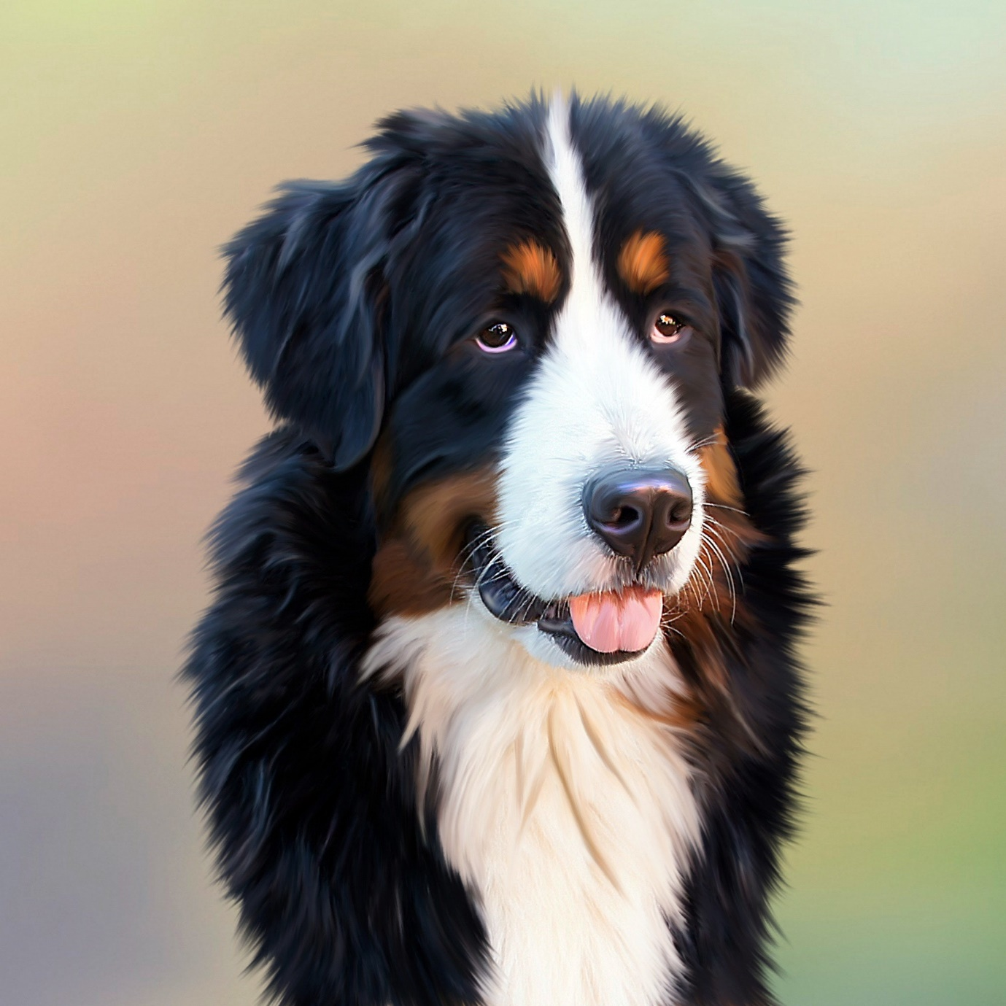

Source: [Pexels](http://pexels.com)

import cv2  
gray_image = cv2.cvtColor(image, cv2.COLOR_BGR2GRAY)  
ret, threshold_image = cv2.threshold(im, 127, 255, 0)  
viewImage(gray_image, "Gray-scale doggo")  
viewImage(threshold_image, "Black & White doggo")

gray_image is the grayscale one-channeled version of the image.This threshold function will turn all shades darker (smaller) than 127 to 0 and all brighter (greater) to 255.

**Another example:**

ret, threshold = cv2.threshold(im, 150, 200, 10)

This will turn all shades smaller than 150 to 10 and all greater to 200.

*More thresholding functions* [*here*](https://docs.opencv.org/3.4/d7/d4d/tutorial_py_thresholding.html)*.*

Image for post

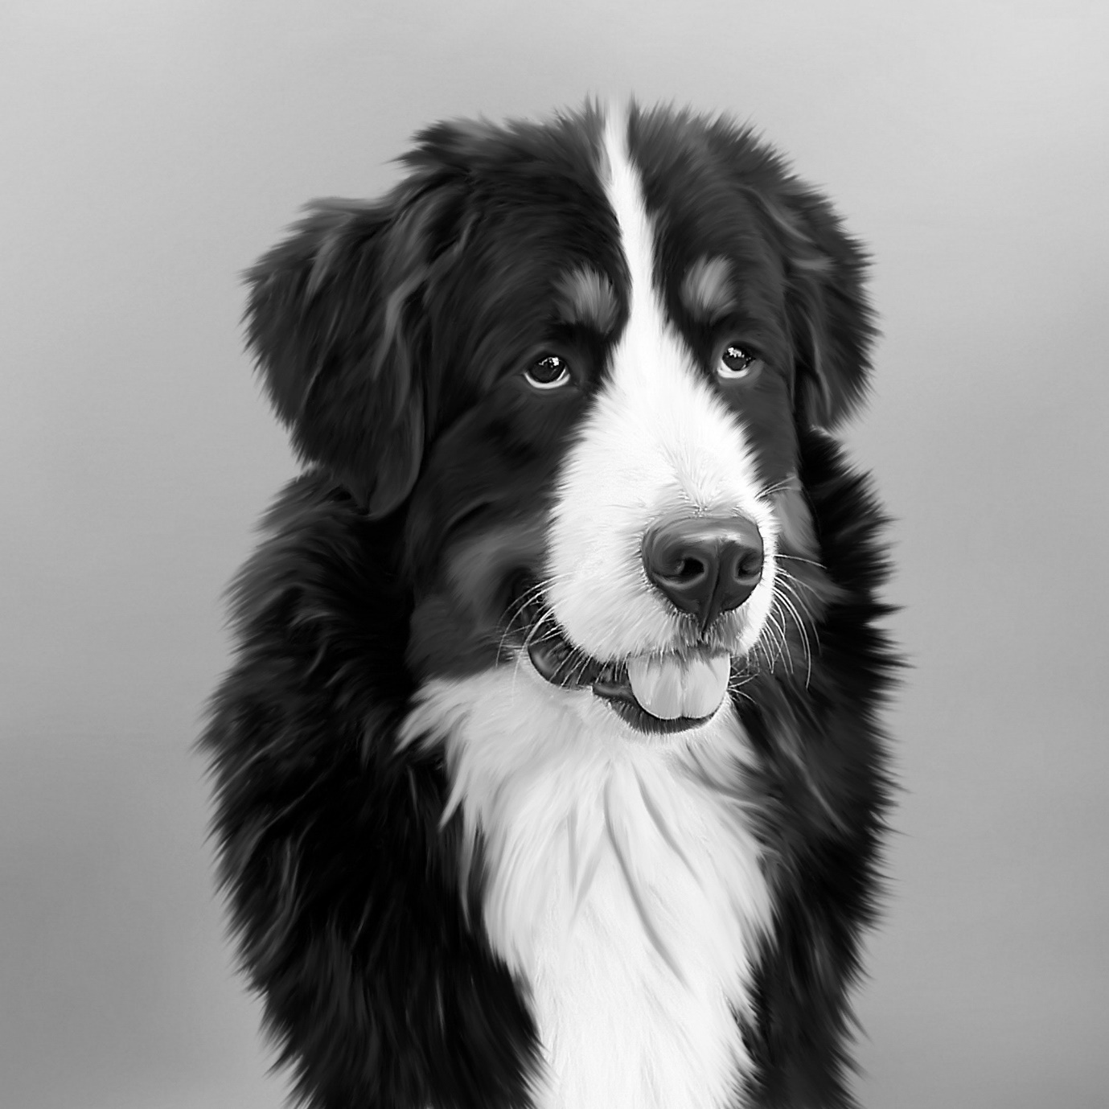

Image for post

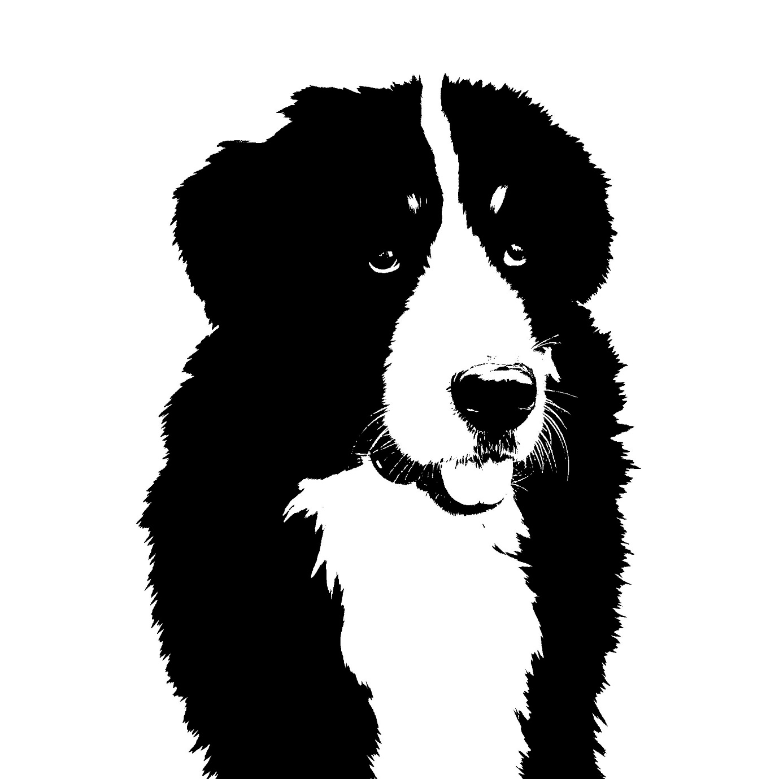

Left: Gray-scale doggo. Right: Black & White doggo.